**Left Navigation Production Notes:**

**Course Home** - Module Page

* Course Announcements
* Instructor Information
* Student Survey

**My Grades** - Added Tool Link

**Course Messages** - Added Tool Link

**Tools** - Added Tool Link

**Add Divider**

**Syllabus** - Added Tool Link

**eText** - Add Course Link

* Location Info - **example** - /Course Materials/eText = This is a course level target
* Add Book Title
  + Course level target setup for **VitalSource eText**
    - Description
    - Personal Data
      * User ID Required by Tool

**Discussion Board** - Added Tool Link - Put Under the Getting Started Content Area

**-------------------------------------------------------------------------------------------------**

#####Begin Topic#####

Name: Getting Started

##Begin Item##

Name: Welcome

Type: page

##End Item##

Welcome to <Mobile Application Development>.

This course is intended to provide an opportunity for you to master enough of the Hypertext Markup Language (HTML) to be able to create well-structured responsive webpages, using jQuery Mobile, o jQuery Mobileevelopment ng a Development Environmentbuilding on a foundation of skills that are used by Web developers in the real world.

We will cover a breadth of related topics, including:

* An overview of HTML and CSS
* An introduction to JavaScript and jQuery Mobile
* Considerations for configuring text, color, graphics, and various Web assets
* Best practices for Web design
* The Web development process
* Using Forms and other interactive features with data on a website

A final project is included as a deliverable during this course; as each module is completed, you will develop a functioning jQuery Mobile website. You will submit a final website during the last module of the course, which you will host on the web, using Rasmussen’s web hosting.

[We will use sample HTML, CSS, and JavaScript files throughout the course. Make sure you download the zip file here](C:\\Users\\Darice\\AppData\\Roaming\\Microsoft\\Word\\Intro to HTML Sample Files for Students.zip). This file is broken out by module to help you follow along week to week.

During this course, we will use the following tools to edit, view, and test your website.

You'll use an **HTML editor** to edit **HTML documents** called Atom, which is Windows and Mac compatible. You may download Atom here. <link to <https://atom.io/>>

For the **web server and website host**, we will use Rasmussen's **FTP (File Transfer Protocol)** host. First you will need a Rasmussen FTP account. Click here on instructions on how to get one. <link to <http://rasmussen.libanswers.com/faq/129759>>

You’ll need a way to **transport** your HTML documents to your web server. We will use FileZilla, which is a Windows and MAC compatible **FTP client**. You can download a copy here. <link to <https://filezilla-project.org/download.php?show_all=1>>

Enjoy the course!

##Begin Item##

Name: Course Schedule

Type: page

##End Item##

<standard content>

##Begin Item##

Name: Start the course

Type: page

##End Item##

Now is a good time to carefully read the Syllabus and the Course Schedule. You should also explore the content in Module 01 of the course, in order to familiarize yourself with the course environment. If you have any questions or technical problems, please contact the Personal Support Center. You may also post any questions to the General Course Questions discussion forum at the end of this section.

On the next screen is the Student Lounge discussion forum. Use this forum to introduce yourself to the class by posting a short message. You might want to include information about yourself such as:

* Your hometown
* Your hobbies or special interests
* Your place of work
* Your reasons for taking this course

We encourage you to respond to your classmates' posts. Your faculty member has posted an introduction; feel free to respond to your faculty member as well.

##Begin Item##

Name: Student Lounge

Type: forum

##End Item##

The **Student Lounge** is an ungraded open forum where you can talk with other students about any topic you want -- for example, the course, the school, a good movie, or a favorite restaurant. Your instructor may also participate in the forum from time to time, but he or she will never grade your conversation.  
  
To get started, use the **Student Lounge** and introduce yourself to your classmates and your instructor. Talk about your educational goals and what achieving those goals will mean for your life. For example, "My goal is to complete my bachelor's degree. This will qualify me for a promotion at work." "I want to complete my associate's in business management and specialize in entrepreneurship so I can open my own restaurant."  
  
Also explain what really motivates you to pursue your education. For example, is it your children? Your parents or grandparents? A dream you have? Specifically, if things get tough, what personal reminder will drive you towards success?

[Need Help? Click here for complete discussion forum instructions.](https://content.learntoday.info/Learn/course_files/help/discussion.html)

##Begin Item##

Name: General Course Questions

Type: forum

##End Item##

Post any general questions about the course to this discussion forum. Your faculty member will respond to your post so the entire class can benefit from the questions and answers. If you know the answer to a particular question, please post an answer.

If you have questions of a personal nature, please email your faculty member directly.

##Begin Item##

Name: About Your Course Materials

Type: page

##End Item##

About Your Course Materials

The primary delivery method of course materials at Rasmussen College is in digital format. Select courses will also have physical materials as well.

Your course digital content can include: materials embedded in your course, videos, webinars and lectures, eTextbooks and more.

You can access embedded course materials directly within your online courses via links.

Your eTextbook is provided to you through a system called VitalSource. Be sure to check your Rasmussen College student email for access to VitalSource.

Rasmussen College has compiled a variety of resources, videos and FAQs for your use. Visit the Rasmussen College Digital Content Hub at [www.rasmussen.edu/DigitalContent](http://www.rasmussen.edu/DigitalContent)

##Begin Item##

Name: Live Classroom Information

Type: forum

##End Item##

**Note:** Collaborating with your peers and faculty is a critical element to your learning. Live Classrooms are a regular opportunity for you and your fellow learners to share dialogue and explore the rich ideas found within this course. Just as important, live classrooms are also an opportunity for you and your fellow learners to share your stories as well as how learning affects your lives. In this class, you will earn points for attending Live Classrooms.

#####End Topic#####

#####Begin Topic#####

Name: Module 01 – Understanding Core Technologies and Configuring a Development Environment

##Begin Item##

Name: Objectives

Type: page

##End Item##

Objectives

By the end of this module you should be able to:

* Recognize widely supported technologies for rendering web pages.
* Be able to identify technologies available in HTML5, such as local storage and geolocation.
* Apply core principles of adaptation technique to planning and early-design phases of a mobile application.
* Identify mobile application basics and development tools.
* Setup and configure mobile application development workspace for multiple platforms.

##Begin Item##

Name: Assignments

Type: page

##End Item##

**Reading -** jQuery Mobile Web Development Essentials Third Edition - chapter 1; Creating Mobile Apps with jQuery Mobile Second Edition - chapter 2

*Activity Time: 6 hours*

**Overview of HTML and CSS**

*Activity Time: 1 hour*

**Introduction to JavaScript**

*Activity Time: 1 hour*

**Introduction to jQuery Mobile**

*Activity Time: 1 hour*

**Website Mockup**

*Activity Time: 1 hour*

**Module 01 Discussion** – Best Practices and Poorly Designed Web Applications

*Activity Time: 2 hours*

*Additional Time for Study, Research, and Reflection: 1 hour*

**Course Project Introduction**

*Activity Time: 30 minutes*

**Module 01 Live Classroom** - Setting Up a Development Environment and Getting Started

*Activity Time: 1 Hour*

**Total Estimated Time: 19.5 hours**

##Begin Item##

Name: Overview of HTML and CSS

Type: page

##End Item##

We will use sample HTML, CSS, and JavaScript files throughout the course. Make sure you download the zip file here. This file is broken out by module to help you follow along week to week.

The Internet and Web

Can you remember a time when we did not have the Internet? How did you communicate with others? Did you write more handwritten letters back then than you do now? How did you pay your bills? Did you mail billing statements in with checks or money orders? How did you place orders for items you heard about or saw on TV? Did you use order catalogs and place orders over the phone or did you fill out an order form and mail it in along with a check or money order for payment? Did you ever write in your credit card number on a form to get billed to your credit card?

Think about how you perform all of these tasks today and how often the Internet is used for each. Now we can use email to communicate via the Internet. Now, when we want information on a product, company, and just about anything of interest, we can go online and search the web.

So what exactly is the Internet and Web? The Internet was started in the 1960s as an interconnected network of computer networks that spans the world. When we refer to the web, we’re referencing the online content that is stored on servers throughout the world. Some countries have more connectivity than others, but we are still capable of communicating almost instantly, versus the old fashioned way. The Internet began as a way to connect computers at research facilities and universities. The idea was that messages could still reach a destination via multiple routes and destinations. If part of the path was broken, such as a computer being down at one of the universities, it could still reach a destination using an alternative path.

Other networks were created and connected over the years and increasing commercial use began to set the stage for electronic commerce in the 1990s. At that time, the Internet was text based and not very easy to use. In 1991, code was created to allow communications between a client computer and web server using **HTTP, or Hypertext Transfer Protocol**. This used **HTML, or Hypertext Markup Language** to format documents.

Think of your favorite shopping website, such as Macys.com. When you visit the website on your browser, and enter the URL, “macys.com”, your browser then interprets that URL into an IP address, and uses **HTTP** to determine where the web content (**HTML**, or everything you see on the home page) is stored, and then it displays it in your browser.

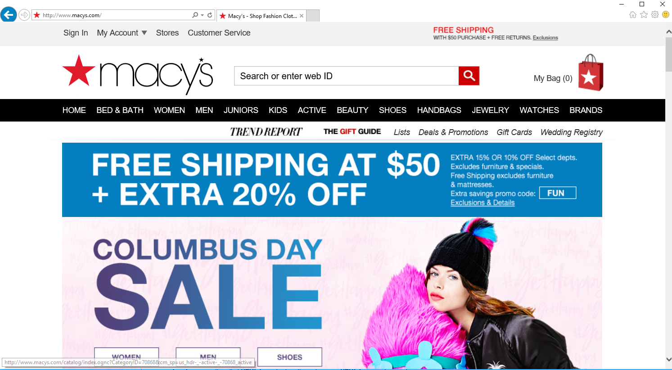

Web Standards and the World Wide Web Consortium (W3c)

The World Wide Web Consortium (W3C) <link to <https://www.w3.org/>> is an international community made up of staff, member organizations, and the public to develop web standards <link to <https://www.w3.org/standards/>>. These standards cover web design, applications, devices, architecture, technology, services, browsers, and authoring tools.

HTML Basics

During this course, we will use the following tools to edit, view, and test your website.

[We will use sample HTML, CSS, and JavaScript files throughout the course. Make sure you download the zip file here](C:\\Users\\dlc59\\Google Drive\\Rasmussen\\Computer Science SME\\1_CEN1400 - Mobile Application Development\\Module 1\\Intro to HTML Sample Files for Students.zip). This file is broken out by module to help you follow along week to week.

During this course, we will use the following tools to edit, view, and test your website.

You'll use an **HTML editor** to edit **HTML documents** called Atom, which is Windows and Mac compatible. You may download Atom here. <link to <https://atom.io/>>

For the **web server and website host**, we will use Rasmussen's **FTP (File Transfer Protocol)** host. First you will need a Rasmussen FTP account. Click here on instructions on how to get one. <link to <http://rasmussen.libanswers.com/faq/129759>>

You’ll need a way to **transport** your HTML documents to your web server. We will use FileZilla, which is a Windows and MAC compatible **FTP client**. You can download a copy here. <link to <https://filezilla-project.org/download.php?show_all=1>>

HTML is a markup language that is used to describe web pages. As we learned earlier, **HTML** stands for **Hyper Text Markup Language**. You should note that HTML is not a programming language; it is a markup language, which is a set of markup tags. HTML uses **markup tags**, usually called **HTML tags**, to describe web pages. **HTML tags** are keywords surrounded by angle brackets. For example:

<html>

HTML tags normally come in pairs like <b> and </b>. The first tag in a pair is the start tag, and the second tag is the end tag.

For example,

<b>Hello World!</b>

Start and end tags are also called opening tags and closing tags. HTML Documents describe web pages and contain HTML tags and plain text.

Let's review a sample HTML document and save it on your own computer. Copy the three files below to your desktop.

(Right click on each link, and select "save target as" or "save link as")

[HTML\mainpage.html](C:\\Users\\dlc59\\Google Drive\\Rasmussen\\Computer Science SME\\1_CEN1400 - Mobile Application Development\\Module 1\\HTML\\mainpage.html)

[HTML\page1.html](C:\\Users\\dlc59\\Google Drive\\Rasmussen\\Computer Science SME\\1_CEN1400 - Mobile Application Development\\Module 1\\HTML\\page1.html)

[HTML\page2.html](C:\\Users\\dlc59\\Google Drive\\Rasmussen\\Computer Science SME\\1_CEN1400 - Mobile Application Development\\Module 1\\HTML\\page2.html)

After you have copied the files, you can double-click on the file called "mainpage.html" and see the web site in action.

Resources

Installing Atom – [document](C:\\Users\\dlc59\\Google Drive\\Rasmussen\\Computer Science SME\\1_CEN1400 - Mobile Application Development\\Module 1\\Installing Atom.docx).

CSS Introduction

We will use sample HTML, CSS, and JavaScript files throughout the course. Make sure you download the zip file here. This file is broken out by module to help you follow along week to week.

CSS stands for Cascading Style Sheets and contains styles define how to display HTML elements. Using External Style Sheets can save a lot of work for a web developer.

Because HTML was never intended to contain tags for formatting a document, if can be a nightmare for a web developer to update fonts and colors on large sites. If a large site containing 20 or more HTML documents containing fonts and colors needed to be updated or changed, it is a long and expensive process.

To solve this problem, the World Wide Web Consortium (W3C) created CSS. In HTML 4.0, all formatting could be removed from the HTML document, and stored in a separate CSS file. All browsers support CSS today.

CSS defines how HTML elements are to be displayed. Styles are normally saved in external .css files. External style sheets enable you to change the appearance and layout of all the pages in a Web site, just by editing one single file.

Here are examples:

[CSS\ex1.html](C:\\Users\\dlc59\\Google Drive\\Rasmussen\\Computer Science SME\\1_CEN1400 - Mobile Application Development\\Module 1\\CSS\\ex1.html)

<html>

<head>

<link rel="stylesheet" type="text/css" href="ex1.css" />

</head>

<body>

<h1>This header is 36 pt</h1>

<h2>This header is blue</h2>

<p>This paragraph has a left margin of 50 pixels</p>

</body>

</html>

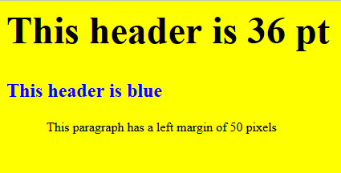

[CSS\ex2.html](C:\\Users\\dlc59\\Google Drive\\Rasmussen\\Computer Science SME\\1_CEN1400 - Mobile Application Development\\Module 1\\CSS\\ex2.html)

<html>

<head>

<link rel="stylesheet" type="text/css" href="ex2.css" />

</head>

<body>

<h1>This is a header 1</h1>

<hr />

<p>You can see that the style sheet formats the text</p>

<p><a href="http://www.google.com" target="\_blank">This is a link</a></p>

</body>

</html>

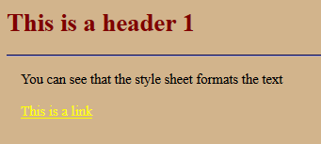

CSS Syntax

A CSS rule has two main parts: a selector, and one or more declarations:

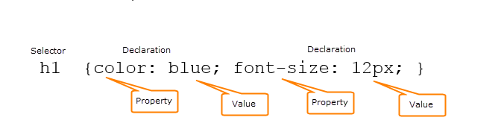

The selector is normally the HTML element you want to style. Each declaration consists of a property and a value. The property is the style attribute you want to change. Each property has a value.

CSS Example

CSS declarations always ends with a semicolon, and declaration groups are surrounded by curly brackets:

p {color:red;text-align:center;}

To make the CSS more readable, you can put one declaration on each line, like this:

p  
{  
color:red;  
text-align:center;  
}

Here is an [CSS\ex3.html](C:\\Users\\dlc59\\Google Drive\\Rasmussen\\Computer Science SME\\1_CEN1400 - Mobile Application Development\\Module 1\\CSS\\ex3.html)

<html>

<head>

<style type="text/css">

p

{

color:red;

text-align:center;

}

</style>

</head>

<body>

<p>Hello World!</p>

<p>This paragraph is styled with CSS.</p>

</body>

</html>

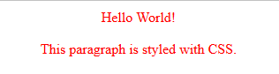

CSS Comments

Comments are used to explain your code, and may help you when you edit the source code at a later date. Comments are ignored by browsers.

A CSS comment begins with "/\*", and ends with "\*/", like this:

/\*This is a comment\*/  
p  
{  
text-align:center;  
/\*This is another comment\*/  
color:black;  
font-family:arial;  
}

CSS Id and Class Selectors

In addition to setting a style for a HTML element, CSS allows you to specify your own selectors called "id" and "class".

The id Selector

The id selector is used to specify a style for a single, unique element. It uses the id attribute of the HTML element, and is defined with a "#".

The style rule below will be applied to the element with id="para1":

[CSS\ex4.html](C:\\Users\\dlc59\\Google Drive\\Rasmussen\\Computer Science SME\\1_CEN1400 - Mobile Application Development\\Module 1\\CSS\\ex4.html)

<html>

<head>

<style type="text/css">

#para1

{

text-align:center;

color:red;

}

</style>

</head>

<body>

<p id="para1">Hello World!</p>

<p>This paragraph is not affected by the style.</p>

</body>

</html>

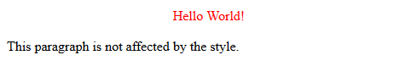

Do NOT start an ID name with a number. It will not work in Mozilla/Firefox.

The class Selector

The class selector is used to specify a style for a group of elements. Unlike the id selector, the class selector is most often used on several elements.

This allows you to set a particular style for any HTML elements with the same class.

The class selector uses the HTML class attribute, and is defined with a "."

In the example below, all HTML elements with class="center" will be center-aligned:

[Example](C:\\Users\\dlc59\\Google Drive\\Rasmussen\\Computer Science SME\\1_CEN1400 - Mobile Application Development\\Module 1\\CSS\\ex5.html)

<html>

<head>

<style type="text/css">

.center

{

text-align:center;

}

</style>

</head>

<body>

<h1 class="center">Center-aligned heading</h1>

<p class="center">Center-aligned paragraph.</p>

</body>

</html>



You can also specify that only specific HTML elements should be affected by a class.

In the example below, all p elements with class="center" will be center-aligned:

[Example](C:\\Users\\dlc59\\Google Drive\\Rasmussen\\Computer Science SME\\1_CEN1400 - Mobile Application Development\\Module 1\\CSS\\ex6.html)

<html>

<head>

<style type="text/css">

p.center

{

text-align:center;

}

</style>

</head>

<body>

<h1 class="center">This heading will not be affected</h1>

<p class="center">This paragraph will be center-aligned.</p>

</body>

</html>

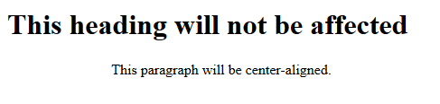

Do NOT start a class name with a number. This is only supported in Internet Explorer.

When a browser reads a style sheet, it will format the document according to it. There are three ways of inserting a style sheet:

* The first, is an **external style sheet**. This is ideal when the style is applied to many pages. With an external style sheet, you can change the look of an entire website by changing one file. Each page must link to the style sheet using the <link> tag. The <link> tag goes inside the head section:

<head>  
<link rel="stylesheet" type="text/css" href="mystyle.css" />  
</head>

An external style sheet can be written in any text editor. The file should not contain any html tags. Your style sheet should be saved with a .css extension. An example of a style sheet file is shown below:

hr {color:sienna;}  
p {margin-left:20px;}  
body {background-image:url("images/back40.gif");}

Do not leave spaces between the property value and the units! "margin-left:20 px" (instead of "margin-left:20px") will work in IE, but not in Firefox or Opera.

* Next is an **internal style sheet**, which should be used when a single document has a unique style. You define internal styles in the head section of an HTML page, by using the <style> tag, like this:

<head>  
<style type="text/css">  
hr {color:sienna;}  
p {margin-left:20px;}  
body {background-image:url("images/back40.gif");}  
</style>  
</head>

* To use **inline styles** you use the style attribute in the relevant tag. The style attribute can contain any CSS property. The example shows how to change the color and the left margin of a paragraph:

<p style="color:sienna;margin-left:20px">This is a paragraph.</p>

Use inline styles sparingly, because it loses many of the advantages of style sheets by mixing content with presentation.

Additional Resources

More on HTML: <http://www.w3schools.com/html/default.asp>

More on CSS: <http://www.w3schools.com/css/default.asp>

##Begin Item##

Name: Introduction to JavaScript

Type: page

##End Item##

We will use sample HTML, CSS, and JavaScript files throughout the course. Make sure you download the zip file here. This file is broken out by module to help you follow along week to week.

JavaScript Introduction

A scripting language is a programming language that helps automate the execution of tasks. There are a number of scripting languages: ASP, JSP, PHP, Python, and JavaScript. For this course, we will focus on JavaScript.

JavaScript is the most popular scripting language that was designed to add interactivity to HTML pages and is usually embedded directly into HTML pages. This language works in all major browsers, such as Internet Explorer, Firefox, Chrome, Opera, and Safari.

Here are some of JavaScript's key features:

* JavaScript is an **interpreted language** which means that scripts execute without having to compile them first. JavaScript is available to use without purchasing a license.
* HTML designers can use JavaScript as a **programming tool**. JavaScript uses a simple syntax that is easier for web designers (who are not always programmers) to borrow "snippets" of code and insert them into HTML.
* JavaScript can be used to add **dynamic text** into an HTML page. For example:
  + A JavaScript statement like this:  
      
    document.write("<h1>" + name + "</h1>")   
      
    can write a variable text into an HTML page.
* JavaScript can **react to events**. For example, when a user clicks on an element or when a page has finished loading, JavaScript can be set to execute something else.
* JavaScript can **read and write HTML elements**, and can also read and change the content of an HTML element.
* When collecting data, in a form, for example, JavaScript can be used to **validate it before it is submitted to a server**. This saves the server from extra processing and can also help to avoid data entry errors.
* JavaScript can be used to **detect the visitor's browser**. This is handy if a particular style or feature is being used on specific browsers. A great example of this is when browser plugins, such as [Chrome Extensions](https://chrome.google.com/webstore/category/extensions) are installed. Before using a Chrome Extension, it must first detect the type of browser the page is loaded on and confirm that you are indeed using a Chrome browser.
* JavaScript can be used to create **cookies**, which are used to store and retrieve information on the visitor's computer. Cookies are text files that contain various information regarding the website visit, such as specific settings, whether you've visited the page in the past, or information you've entered into a web form.

Inserting JavaScript into an HTML document

The HTML <script> tag is used to insert a JavaScript into an HTML document. Inside the <script> tag, you need to use the type attribute to define the scripting language. In the example below, the <script type="text/javascript"> and </script> tells where the JavaScript begins and ends.

<html>  
<body>  
<script type="text/javascript">  
...  
</script>  
</body>  
</html>

[Example (Filename: jsintro1.html):](C:\\Users\\dlc59\\Google Drive\\Rasmussen\\Computer Science SME\\1_CEN1400 - Mobile Application Development\\Module 1\\JavaScript\\jsintro1.html)

<html>  
<body>  
<script type="text/javascript">  
document.write("Hello World!");  
</script>  
</body>  
</html>

Here’s how it appears in a browser:



The example below shows how to add HTML tags to the JavaScript:

[Example (Filename: jsintro2.html):](C:\\Users\\dlc59\\Google Drive\\Rasmussen\\Computer Science SME\\1_CEN1400 - Mobile Application Development\\Module 1\\JavaScript\\jsintro2.html)

<html>  
<body>  
<script type="text/javascript">  
document.write("<h1>Hello World!</h1>");  
</script>  
</body>  
</html>

Here’s how it appears in a browser:

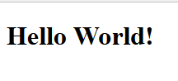

Document.Write Command

The document.write command is a standard JavaScript command for writing output to a page. By entering the document.write command between the <script> and </script> tags, the browser will recognize it as a JavaScript command and execute the code line. In the example below, the browser will write Hello World! to the page:

<html>  
<body>  
<script type="text/javascript">  
document.write("Hello World!");  
</script>  
</body>  
</html>

If you do not use the <script> tag, the browser would have treated the document.write("Hello World!") command as pure text, and just write the entire line on the page. Here's an [example (Filename: jsintro3.html).](C:\\Users\\dlc59\\Google Drive\\Rasmussen\\Computer Science SME\\1_CEN1400 - Mobile Application Development\\Module 1\\JavaScript\\jsintro3.html)

JavaScript Placement

JavaScripts can be inserted in the body and in the head sections of an HTML page. JavaScripts in a page will be executed immediately while the page loads into the browser. This is not always intended. Sometimes you may want to execute a script when a page loads, or at a later event, such as when a user clicks a button.

When this is the case, you should put the script inside a function, you will learn about functions in a future lesson.

**Scripts in <head>**

Scripts to be executed when they are called, or when an event is triggered, are placed in functions. You should put your functions in the head section, this way they are all in one place, and they do not interfere with page content.

[Example (Filename: jsintro4.html)](C:\\Users\\dlc59\\Google Drive\\Rasmussen\\Computer Science SME\\1_CEN1400 - Mobile Application Development\\Module 1\\JavaScript\\jsintro4.html)

<html>  
<head>  
<script type="text/javascript">  
function message()  
{  
alert("This alert box was called with the onload event");  
}  
</script>  
</head>  
  
<body onload="message()">  
</body>  
</html>

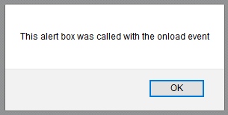

Scripts in <body>

If you don't want your script to be placed inside a function, or if your script should write page content, it should be placed in the body section.

[Example (Filename: jsintro5.html)](C:\\Users\\dlc59\\Google Drive\\Rasmussen\\Computer Science SME\\1_CEN1400 - Mobile Application Development\\Module 1\\JavaScript\\jsintro5.html)

<html>  
<head>  
</head>  
  
<body>  
<script type="text/javascript">  
document.write("This message is written by JavaScript");  
</script>  
</body>  
  
</html>

Scripts in <head> and <body>

You can place an unlimited number of scripts in your document. Therefore, you can have scripts in both the body and the head section.

[Example (Filename: jsintro6.html)](C:\\Users\\dlc59\\Google Drive\\Rasmussen\\Computer Science SME\\1_CEN1400 - Mobile Application Development\\Module 1\\JavaScript\\jsintro6.html)

<html>  
<head>  
<script type="text/javascript">  
function message()  
{  
alert("This alert box was called with the onload event");  
}  
</script>  
</head>  
  
<body onload="message()">  
<script type="text/javascript">  
document.write("This message is written by JavaScript");  
</script>  
</body>  
</html>

Using an External JavaScript

If you want to run the same JavaScript on several pages, without having to write the same script on every page, you can write a JavaScript in an external file.

Save the external JavaScript file with a .js file extension.

Note: The external script cannot contain the <script></script> tags.

To use the external script, point to the .js file in the "src" attribute of the <script> tag:

[Example (Filename: jsintro7.html)](C:\\Users\\dlc59\\Google Drive\\Rasmussen\\Computer Science SME\\1_CEN1400 - Mobile Application Development\\Module 1\\JavaScript\\jsintro7.html)

<html>  
<head>  
<script type="text/javascript" src="rasmussen.js"></script>  
</head>  
<body>  
</body>  
</html>

Here is JavaScript used in the [example (Filename: rasmussen.js) :](C:\\Users\\dlc59\\Google Drive\\Rasmussen\\Computer Science SME\\1_CEN1400 - Mobile Application Development\\Module 1\\JavaScript\\rasmussen.js)

document.write("This text was written by an external script!")

Resources:

JavaScript: https://www.javascript.com

JavaScript Resources: <https://www.javascript.com/resources>

##Begin Item##

Name: Introduction to jQuery Mobile

Type: page

##End Item##

jQuery Mobile Framework

We will use sample HTML, CSS, and JavaScript files throughout the course. Make sure you download the zip file here. This file is broken out by module to help you follow along week to week.

The sample app is built using the jQuery mobile framework (jQuery Mobile **<link to <http://jquerymobile.com/>>)**. The jQuery Mobile framework is a touch optimized, JavaScript library. The framework provides a collection of various touch components, such as buttons or lists. It also contains many common mobile design elements, like headers, footers, and tab navigation bars.

jQuery Mobile CDN

jQuery Mobile has what is called a CDN or Content Delivery Network. This site is used to distribute the most recent builds of the framework. It also helps speed up download time for the end user.

Always make sure you download the latest stable build from the jQuery Mobile site. The latest stable build contains ALL features and code to use all available jQuery Mobile features. The jQuery Mobile website maintains an up to date list of CDNs containing \*.css and \*.js here: <https://jquerymobile.com/download/> . The most recent stable versions are listed under the heading, “Latest stable version”.

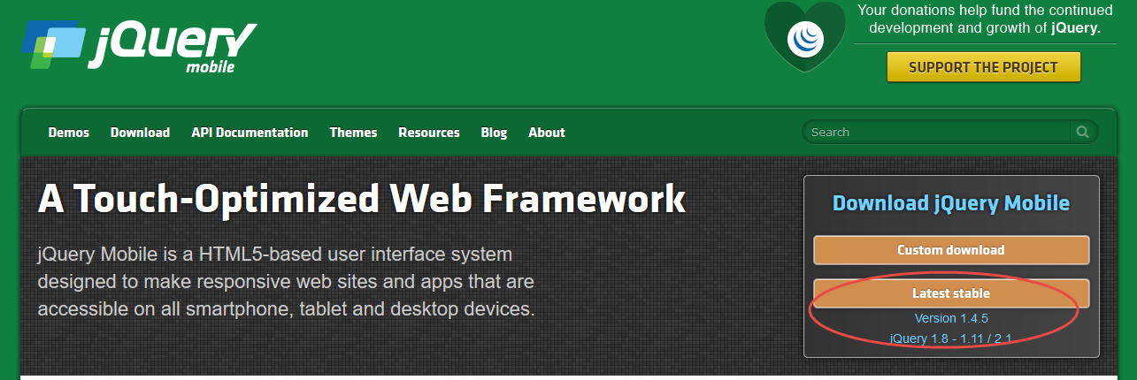

Buttons

A button in jQuery Mobile can be created in three ways:

* Using the <input> element:
  + <input type="button" value="Button">
* Using the <button> element with class="ui-btn":
  + <button class="ui-btn">Button</button>
* Using the <a> element with class="ui-btn"
  + <a href="#anylink" class="ui-btn">Button</a>

Thanks to the jQuery Mobile framework, buttons are automatically styled so that they are immediately usable on mobile devices, tablets, and desktop PCs.

It is recommended that you use the <a> element with class="ui-btn" to link between pages, and <input> or <button> elements for form submission.

Navigation Buttons

To link between pages by buttons, use the <a> element with class="ui-btn".

For example:

<a href="#pagetwo" class="ui-btn">Go to Page Two</a>

Grouping Buttons Together

To group buttons together horizontally or vertically, you should use the data-role="controlgroup" attribute together with data-type="horizontal|vertical" in a container element, to specify whether to group buttons.

For example:

<div data-role="controlgroup" data-type="horizontal">  
  <a href="#" class="ui-btn">Button 1</a>  
  <a href="#" class="ui-btn">Button 2</a>  
  <a href="#" class="ui-btn">Button 3</a>  
</div>

By default, when you vertically group buttons, no margins and space between them. Also, only the first and the last button has rounded corners, which creates a nice look when grouped together.

Back Button

It’s standard practice to provide a way for the user to return to a previous location. To create a Back button, use the data-rel="back" attribute (Note: this will ignore the anchor's href value).

For example:

<a href="#" class="ui-btn" data-rel="back">Go Back</a>

Icons

The jQuery Mobile framework provides a set of icons that will make your buttons look more aesthetically pleasing. To add an icon to your button, use the ui-icon class, and position the icon with an icon position class (ui-btn-icon-pos).

For example:

<a href="#anylink" class="ui-btn ui-icon-search ui-btn-icon-left">Search</a>

Toolbars

Toolbars are often placed inside headers and footers for easier access and navigation. jQuery has a number of predefined toolbars that can be used for navigation: <http://demos.jquerymobile.com/1.4.5/toolbar/>

Page Transitions

Page transitions are jQuery Mobile effects that take advantage of mobile browsers advanced CSS3 capabilities to handle transforms and transitions. Transitions are added to links with the attribute "data-transition".

Note: To achieve the transition effect, the browser must support CSS3 3D Transforms:

|  |  |  |  |  |  |
| --- | --- | --- | --- | --- | --- |
| Browser Type | Chrome | Internet Explorer | Firefox | Safari | Opera |
| Version | 12.0 | 10.0 | 16.0 | 4.0 | 15.0 |

The transition effect can be applied to any link or form submission by using the data-transition attribute:

<a href="#anylink" data-transition="slide">Slide to Page Two</a>

Here are other types of transitions that can be used:

|  |  |
| --- | --- |
| Transition | Description |
| fade | Default. Fades to the next page |
| flip | Flips to the next page from back to front |
| flow | Throws the current page away and comes in with the next page |
| pop | Goes to the next page like a popup window |
| slide | Slides to the next page from right to left |
| slidefade | Slides from right to left and fades in the next page |
| slideup | Slides to the next page from bottom to top |
| slidedown | Slides to the next page from top to bottom |
| turn | Turns to the next page |
| none | No transition effect |

Resources:

HTML Script Src: <http://www.w3schools.com/TAGS/att_script_src.asp>

jQuery Mobile Tutorial: <http://www.w3schools.com/jquerymobile/>

jQuery Mobile Data Attributes: <http://www.w3schools.com/jquerymobile/jquerymobile_ref_data.asp>

jQuery Mobile CSS Classes: <http://www.w3schools.com/jquerymobile/jquerymobile_ref_css.asp>

jQuery Mobile Icons Reference: <http://www.w3schools.com/jquerymobile/jquerymobile_ref_icons.asp>

jQuery Mobile Demos

##Begin Item##

Name: Website Mockup

Type: page

##End Item##

We will use sample HTML, CSS, and JavaScript files throughout the course. Make sure you download the zip file here. This file is broken out by module to help you follow along week to week.

When it comes to developing websites, the process is very similar to building a home. Would you ever begin building a home without some type of blueprint or plan? If so, what are some of the problems you'd think you'd face in the future? Poor construction, bad plumbing, awkward entries and closets, and did you forget to place a stairway to get to the second floor?

A similar concept applies when it comes to website development. A website development cycle follows specific steps to ensure the site is built according to the plan from the conceptualization, production, testing, launch, and maintenance. The diagram below outlines the general website Development cycle:

Determining the architecture and building a website mockup takes place during the design phase. Before creating a new site, you should first build a blueprint website mockup. This involves:

* **Determining the site’s organizational structure.** There are three basic types: hierarchical, linear, and random. You should determine the best structure for your site and create a site map.
  + **Hierarchical** – The home page is at the top of the navigation, with a clear navigation and top down structure.
  + **Linear** – A series of pages that must appear in sequence, such as a story, tutorial, or presentation.
  + **Random** – A series of pages that have no clear path and are connected in various ways.
* **Designing a prototype, which can start out as a sketched design on paper.** You may then want to use a graphics application to create sample web page mock-ups, or wireframes. Designers often use these tools to show prototypes to clients to gain approval on the initial design. [Here’s an example of a simple wireframe.](sample_mockup.docx)
* **You'd then need to determine a page layout.** This involves the aesthetics of the site and layout, and details such as color schemes, the size of logos and images, and the fonts being used. You should follow a page layout design and site map to create sample layouts for the home page and content pages of your site. This helps you get a better idea of how the site should function.
* **You should document each page that you'd like to add to the site and create a document that contains the specifications.** The specifications should describe the functionality of the page, and any text, graphics, and images that will be used on the page. If you're designing the website for a client, you'd also add a section for client approval/sign off. This way your client's approval will be documented and you can begin the project knowing that you're all on the same page when it comes to the content, layout, functionality, and design.

##Begin Item##

Name: Module 01 Discussion - "Bad" Web Design

Type: forum

##End Item##

We all have favorite websites that we visit daily. Select one that interests you and take a screenshot of the home page of the site. In your discussion post, write a summary that answers the following questions:

* What is the URL of the site?
* What is the purpose and intended audience of the site?
* Is the site mobile friendly?
* Do you think that the site reaches its intended audience? Why or why not?

In your response post, select one of your classmates’ posts and answer the following questions:

* Do you think the site is useful? Why or why not?
* Does this site appeal to you?
* Did you experience issues when you used a mobile device to browse to the URL? If so, provide examples.
* Would you encourage others to visit this site? Why or why not?
* How could this site be improved?

<New 5.5 Week discussion footer follows>

Due dates for your initial and response posts can be found by checking the Course Syllabus and Course Calendar.

Need Help? Click here for complete discussion forum instructions.

##Begin Item##

Name: Module 01 Course Project - Introduction

Type: page

##End Item##

Project Overview

You will create a mobile web application that will allow the user to select from a list of favorite items of your choice, such as restaurants, books, artists, TV shows, and so on. Your application must:

* It must use HTML5, CSS3, and the jQuery Mobile framework.
* It must be cross-browser compatible or viewable on popular browsers such as Chrome, Firefox, Internet Explorer, or Safari.
* It must be responsive and viewable on multiple devices.
* It must be original work and include comments throughout your code.
* It must be uploaded to Rasmussen FTP.
* It must include multiple attributes that are covered throughout this course.
* You must use an **HTML editor** to edit **HTML documents** called Atom, which is Windows and Mac compatible. You may download Atom here. <link to <https://atom.io/>>
* For the **web server and website host**, you must use Rasmussen's **FTP (File Transfer Protocol)** host. First you will need a Rasmussen FTP account. Click here on instructions on how to get one. <link to <http://rasmussen.libanswers.com/faq/129759>>

Due Date

**Your final project is due in Module 06.** There will be individual assignments along the way. The module they are due is noted in the time line below.

Time Line

|  |  |
| --- | --- |
| Module | Assignment |
| **01** |  |
| **02** |  |
| **03** |  |
| **04** |  |
| **05** |  |
| **06** |  |

Requirements

This project must have a title and table of contents. There is no length requirement besides making sure that all requirements of the assignment are met. The project must have two references for each assignment. You can use your book as one reference and any search engine for additional references. Wikipedia is not a creditable website and may not be used. You may also import pictures, but it is not required.

Evaluation

Each assignment leading up to the final assignment is evaluated and graded independently. Your instructor will provide specific grading criteria for each step of the project prior to its due date.

For Further Questions

If you have further questions throughout this project, please ask your Instructor. Post ideas and questions for your classmates in the General Course Questions forum in the Getting Started folder of this course.

##Begin Item##

Name: Module 01 Course Project - Website Mockup and Your First Home Page

Type: Drop Box

##End Item##

Create a mockup of your web application that will display a list of favorites. Remember, this can be a list of any favorite items, such as books, movies, restaurants, music, and so on. Your web application should contain at least 3 pages (HTML documents). Your mockup should contain mockups of each HTML document. You should follow a similar format as the sample mockup provided [here](sample_mockup.docx) <link to sample\_mockup.docx in the media folder>. Your 5-6-page document should include the following:

* A description of the site’s organizational structure.
* A description of each page that you'd like to add to the site and its specifications, including color schemes, the size of logos and images, and the fonts being used.

Create your first home page. Your home page must include the following elements:

* At least 1 heading.
* At least 2 paragraphs.

You must use FileZilla to upload your HTML document to your Rasmussen FTP account. You must include the URL to your new website in your document. Your URL should follow this format:

http://sotd.us/firstnamelastname/yourwebsitefolder/index.html

or

http://sotd.us/joesmith/project/index.html

Submit your completed assignment by following the directions linked below. Please check the **Course Calendar**for specific due dates.

Save your assignment as a Microsoft Word document. (Mac users, please remember to append the ".docx" extension to the filename.) The name of the file should be your first initial and last name, followed by an underscore and the name of the assignment, and an underscore and the date. An example is shown below:

Jstudent\_exampleproblem\_101504

Submit your completed assignment by following the directions linked below. Please check the **Course Calendar**for specific due dates.

Save your assignment as a Microsoft Word document. (Mac users, please remember to append the ".docx" extension to the filename.) The name of the file should be your first initial and last name, followed by an underscore and the name of the assignment, and an underscore and the date. An example is shown below:

Jstudent\_exampleproblem\_101504

[Need Help? Click here for complete drop box instructions.](https://content.learntoday.info/Learn/course_files/help/dropbox.html)

##Begin Item##

Name: Module 01 Live Classroom - Setting Up a Development Environment and Getting Started

Type: HTML

##End Item##

**<Insert live classroom exam from course: "Demo - Course Template Files" Tie to gradebook at XX points.>**

#####End Topic#####

#####Begin Topic#####

Name: Module 02 - HTML Formatting, Styles, Links, Images

##Begin Item##

Name: Objectives

Type: page

##End Item##

**Objectives**

By the end of this module you should be able to:

* Define HTML, CSS, and JavaScript by reviewing basic HTML tags and CSS stylesheets.
* Add and change HTML tags by creating and editing HTML web pages.

##Begin Item##

Name: Assignments

Type: page

##End Item##

**Reading -** *Web Development and Design Foundations with HTML5*, 8th ed., Chapters 4, 7, and 9

*Activity Time: 6 hours*

**Course Content**

*Activity Time:*

**Module 02 Written Assignment** - Title

*Activity Time:*

*Additional Time for Study, Research, and Reflection:*

**Module 02 Discussion** - Title

*Activity Time:*

*Additional Time for Study, Research, and Reflection:*

**Module 02 Quiz**

*Activity Time:*

*Additional Time for Study, Research, and Reflection:*

**Module 02 Live Classroom**

*Activity Time: 1 Hour*

**Total Estimated Time:**

##Begin Item##

Name: Simple HTML Page and jQuery Mobile

Type: page

##End Item##

Simple HTML Page and jQuery Mobile

In this section, we will create a very simple HTML page and apply the jQuery Mobile styling.

You'll use an **HTML editor** to edit **HTML documents** called Atom, which is Windows and Mac compatible. If you did not download Atom in Module 01, you may download it here. <link to <https://atom.io/>>

Setting up a jQuery Mobile Page

To setup a jQuery Mobile page, you don’t need to download anything to your computer. You just need to reference the jQuery stylesheets (\*.css) and JavaScript libraries (\*.js) in the head section of an HTML page in order to use the framework using the ‘<script> src’ attribute. Here’s an example:

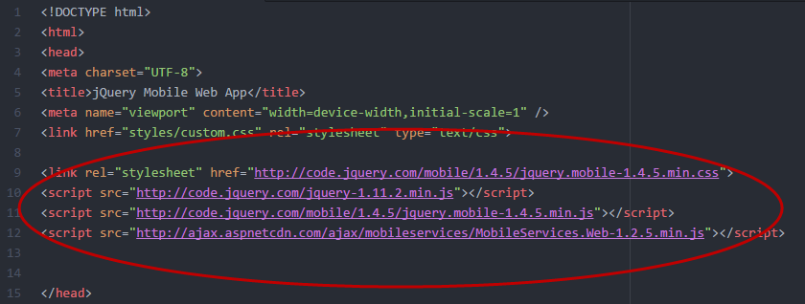

Setting up Page Divs

Click [here](../Module%202/Sample_App.zip) to download the [Sample App](../Module%202/Sample_App.zip). After downloading, extract the file and open ‘index.html’ to see how this page will appear in your browser or device.

jQuery mobile objects are used to building app pages JQuery mobile pages are comprised of divs with the data roll attribute set to page. Let’s try to create a new page using jQuery Mobile. Open Atom.io and type in the HTML below.

<html>

<head>

<meta charset="UTF-8">

<title>jQuery Mobile Web App</title>

<meta name="viewport" content="width=device-width,initial-scale=1" />

<link href="styles/custom.css" rel="stylesheet" type="text/css">

<link rel="stylesheet" href="http://code.jquery.com/mobile/1.4.5/jquery.mobile-1.4.5.min.css">

<script src="http://code.jquery.com/jquery-1.11.2.min.js"></script>

<script src="http://code.jquery.com/mobile/1.4.5/jquery.mobile-1.4.5.min.js"></script>

<script src="http://ajax.aspnetcdn.com/ajax/mobileservices/MobileServices.Web-1.2.5.min.js"></script>

</head>

<body>

<div data-role="page">

<div data-role="header">

<h1>My First jQuery Mobile Page</h1>

</div>

<div data-role="main" class="ui-content">

<p>Welcome to my first new jQuery Mobile page!</p>

</div>

<div data-role="footer">

<h1>Footer Text</h1>

</div>

</div>

</body>

</html>

Save the file as ‘my\_first\_jquery\_mobile\_page.html’. Now, open the page in your browser.

Here’s how it will appear:

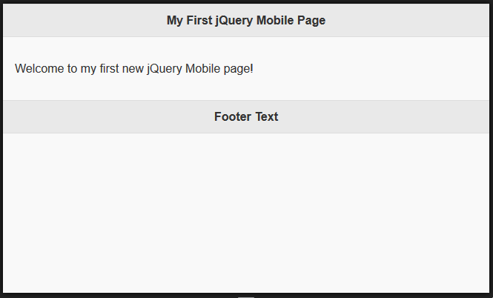

Let’s back up a moment and explain the different components of the HTML you just typed.

* The data-role="page" is the page displayed in the browser
* The data-role="header" creates a toolbar at the top of the page (often used for title or search buttons)
* The data-role="main" defines the content of the page, like text, images, buttons, forms, etc.
* The "ui-content" class adds extra padding and margin inside the page content
* The data-role="footer" creates a toolbar at the bottom of the page

Inside these containers, you can add any HTML elements - paragraphs, images, headings, lists, and so on. You can also create multiple pages in a single HTML file. You’ve already seen this when you downloaded the [Sample App file](Sample_App.zip). Other examples of jQuery Mobile Data Attributes can be found here: <http://www.w3schools.com/jquerymobile/jquerymobile_ref_data.asp>.

Let’s modify the file we just created and add multiple pages:

<html>

<head>

<meta charset="UTF-8">

<title>jQuery Mobile Web App</title>

<meta name="viewport" content="width=device-width,initial-scale=1" />

<link href="styles/custom.css" rel="stylesheet" type="text/css">

<link rel="stylesheet" href="http://code.jquery.com/mobile/1.4.5/jquery.mobile-1.4.5.min.css">

<script src="http://code.jquery.com/jquery-1.11.2.min.js"></script>

<script src="http://code.jquery.com/mobile/1.4.5/jquery.mobile-1.4.5.min.js"></script>

<script src="http://ajax.aspnetcdn.com/ajax/mobileservices/MobileServices.Web-1.2.5.min.js"></script>

</head>

<body>

<div data-role="header">

<h1>My First jQuery Mobile Page</h1>

</div>

<div data-role="page" id="pageone">

<div data-role="main" class="ui-content">

<a href="#pagetwo">Go to Page Two</a>

</div>

</div>

<div data-role="page" id="pagetwo">

<div data-role="main" class="ui-content">

<a href="#pageone">Go to Page One</a>

</div>

</div>

<div data-role="footer">

<h1>Footer Text</h1>

</div>

</div>

</body>

</html>

Save the file and refresh it in your browser. Here’s how the page will now appear:

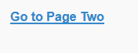

When you click the link ‘Go to Page Two’, here’s how the page appears:

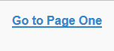

You can also add dialogue boxes to your page. Let’s modify the page so the HTML looks like below:

<html>

<head>

<meta charset="UTF-8">

<title>jQuery Mobile Web App</title>

<meta name="viewport" content="width=device-width,initial-scale=1" />

<link href="styles/custom.css" rel="stylesheet" type="text/css">

<link rel="stylesheet" href="http://code.jquery.com/mobile/1.4.5/jquery.mobile-1.4.5.min.css">

<script src="http://code.jquery.com/jquery-1.11.2.min.js"></script>

<script src="http://code.jquery.com/mobile/1.4.5/jquery.mobile-1.4.5.min.js"></script>

<script src="http://ajax.aspnetcdn.com/ajax/mobileservices/MobileServices.Web-1.2.5.min.js"></script>

</head>

<body>

<div data-role="header">

<h1>My First jQuery Mobile Page</h1>

</div>

<div data-role="page" id="pageone">

<div data-role="main" class="ui-content">

<a href="#pagetwo">Go to Page Two</a>

</div>

</div>

<div data-role="page" data-dialog="true" id="pagetwo">

<div data-role="main" class="ui-content">

<a href="#pageone">Go to Page One</a>

</div>

</div>

<div data-role="footer">

<h1>Footer Text</h1>

</div>

</div>

</body>

</html>

This time when you click ‘Go to Page Two’ you’ll see a dialogue box appear like this:

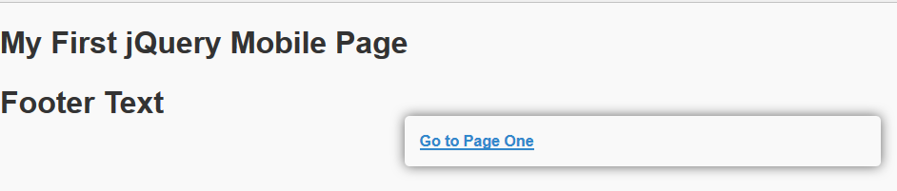

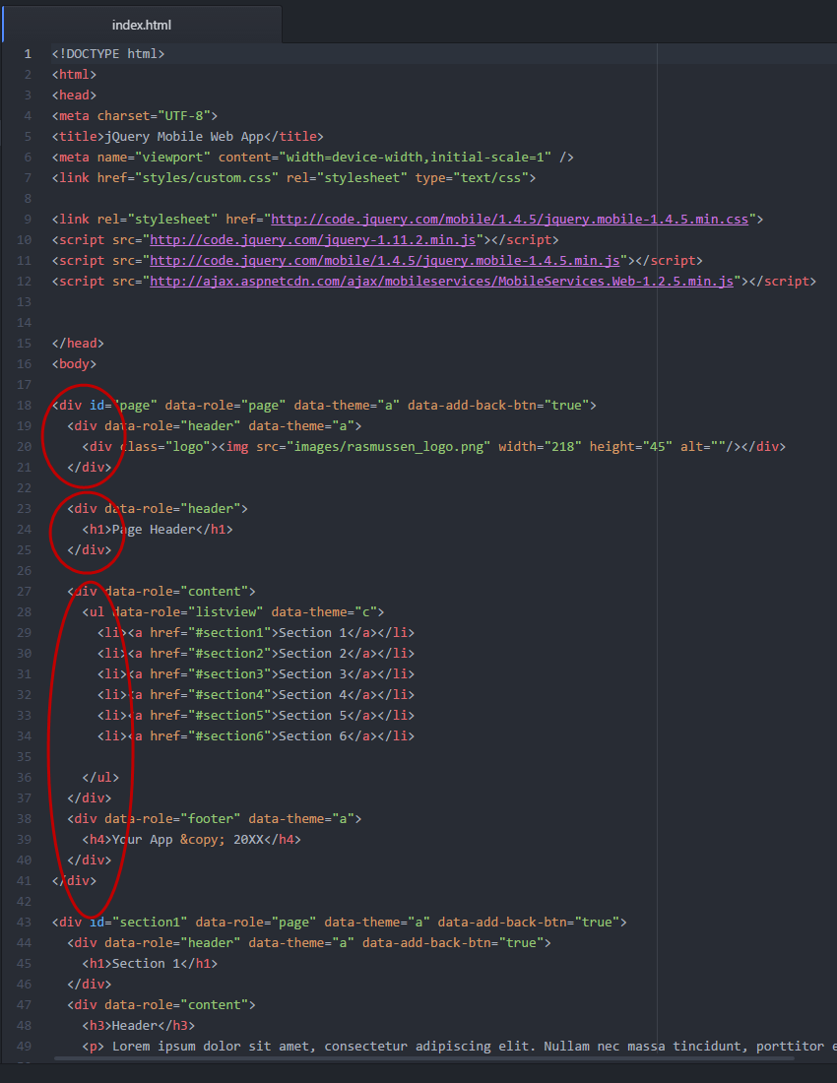

Here’s how the page will look in your browser. Try resizing your browser window to experience the responsiveness of the layout.

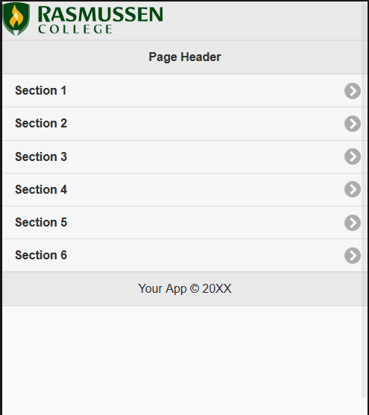

Notice that when you resize the page, the text will remain the same, but the styling and sizes of the divs will change depending on the window size.

Here’s a view of the page at 360x640:

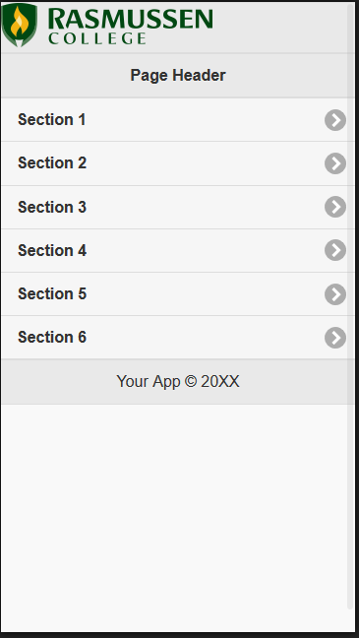

Here’s a view at 320x480:

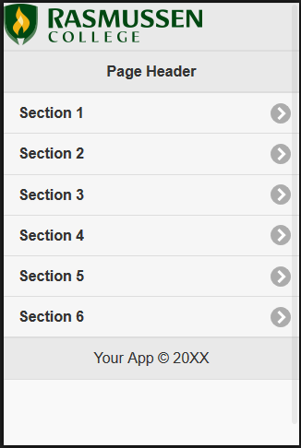

And another view at 230x418:

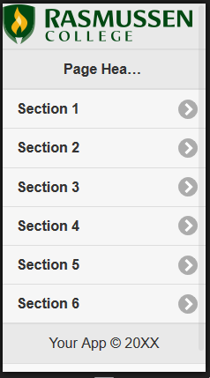

Resources:

HTML Script Src: <http://www.w3schools.com/TAGS/att_script_src.asp>

jQuery Mobile Tutorial: <http://www.w3schools.com/jquerymobile/>

jQuery Mobile Data Attributes: <http://www.w3schools.com/jquerymobile/jquerymobile_ref_data.asp>

##Begin Item##

Name: jQuery Mobile Data Attributes

Type: page

##End Item##

jQuery Data Attributes

You'll use an **HTML editor** to edit **HTML documents** called Atom, which is Windows and Mac compatible. If you did not download Atom in Module 01, you may download it here. <link to <https://atom.io/>>

Click [here](../Module%202/Sample_App.zip) to download the [Sample App](../Module%202/Sample_App.zip). After downloading, extract the file and open ‘index.html’ using Atom.io to view the HTML.

HTML5 data-\* Attribute

jQuery Mobile uses what is called the HTML5 data-\* attribute. This helps create an application that looks attractive on mobile or tablet devices, and is “touch-friendly”, compared to more traditional HTML websites. HTML5 data-\* attributes are used to store custom data that is private to the page or application. This gives developers the ability to embed custom data attributes on all HTML elements.

The data-\* attribute is made up of 2 parts:

1. The attribute name, which is always lowercase, and follows the prefix “data-“
2. The attribute value, which varies depending on the attribute.

Button elements, toolbar links, and input fields are automatically styled as buttons, so you don’t need to use data-role=button. These can be styled using [CSS classes](http://www.w3schools.com/jquerymobile/jquerymobile_ref_css.asp) instead.

Sample App and Data-\* Attributes

Let’s start with the first DIV on lines 18 - 25.

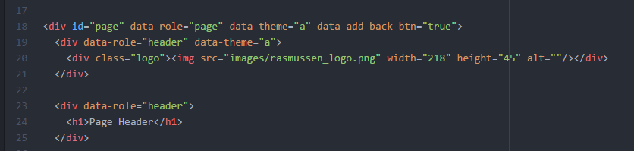

* Line 18: data-role=”page”
  + This displays the page.
* Lines 18, 19: data-theme=”a”
  + This determines what theme to use from the CSS styling.
* Line 18: data-add-back-btn=”true”
  + This adds a back button.
* Line 23: data-role=”header”
  + This displays the header section.

Lines 18-25 display the following section of the page:

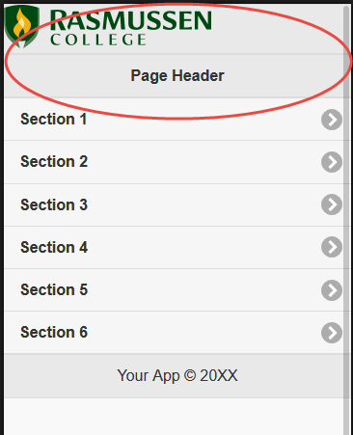

Now let’s review lines 27 – 37.

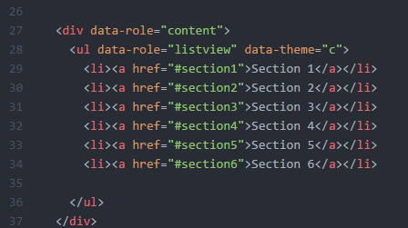

These lines use the following data-\* attributes:

* Line 27: data-role=”content”
  + Displays a content section.
* Line 28: data-role=”listview”
  + Used to display “subpages” or sections of the page.
* Line 28: data-theme=”c”
  + Displays another theme.

These lines display the Sections 1 through 6 on the page:

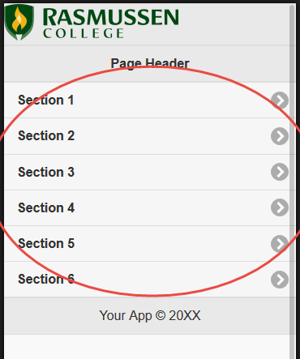

Let’s move on to lines 38 – 41.

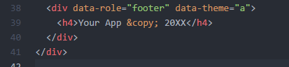

These lines use the following data-\* attributes:

* Line 38: data-role=”footer”
  + Displays a footer section.
* Line 28: data-theme=”a”
  + Displays another theme.

These lines display the footer section of the page:

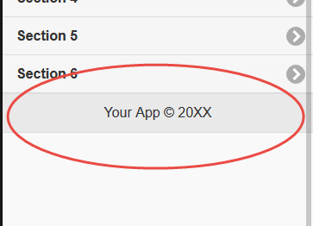

Now let’s review what is displayed when the user touches ‘Section 1’. The HTML used to create the section is in lines 43 – 54.

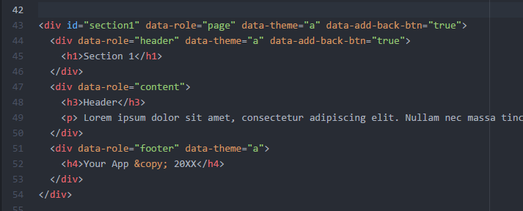

This DIV uses the following data-\* attributes:

* Line 43: data-role=”page”
  + Displays a sub page section.
* Line 43, 44, 51: data-theme=”a”
  + Displays another theme.
* Line 43: data-add-back-btn="true"
  + Displays a back button.
* Line 44: data-role="header"
  + Displays the header of Section 1
* Line 47: data-role="content"
  + Displays the content section of Section 1.
* Line 51: data-role="footer"
  + Displays the footer section.

When the user clicks on ‘Section 1’, this will display the subpage:

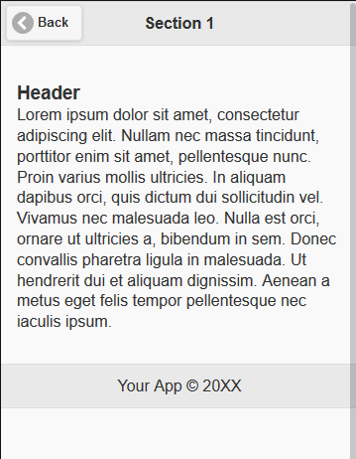

Sections 2 through 6 use the same format as Section 1.

Additional data attributes can be found here: <https://api.jquerymobile.com/data-attribute/>

Resources:

HTML5 data-\* Attributes: <http://www.w3schools.com/tags/att_global_data.asp>

jQuery Data Attributes: <http://www.w3schools.com/jquerymobile/jquerymobile_ref_data.asp>

jQuery CSS Classes: <http://www.w3schools.com/jquerymobile/jquerymobile_ref_css.asp>

##Begin Item##

Name: Working with Links

Type: page

##End Item##

Working with Links

Now let’s review lines 27 – 37 again. Lines 28 – 36 use the [HTML tag ‘ul’](http://www.w3schools.com/tags/tag_ul.asp) to create an unordered HTML list to display the buttons or sections that you see in your browser.



The <ul> tag defines an unordered (bulleted) list. The <li> tag is use to define each line item in the list.

‘a href’ is an HTML attribute that specifies the URL of the page the link should go to. In this case, notice that instead of a URL or HTML document, the text in quotes contains a hash symbol and text, such as “#section1”. This links the button to the DIV on line 43, ‘id=”section1’.

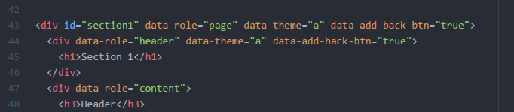

Sections 2- 6 are configured in the same manner.



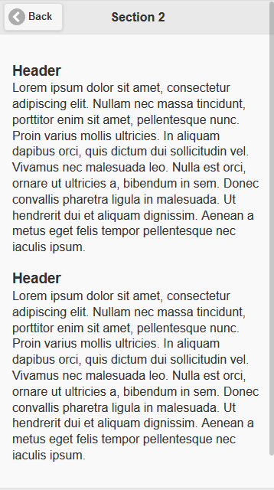

Resources

HTML Links: <http://www.w3schools.com/html/html_links.asp>

##Begin Item##

Name: Practice Adding a Page with Links

Type: Drop Box

##End Item##

Submit your completed assignment by following the directions linked below. Please check the **Course Calendar**for specific due dates.

Save your assignment as a Microsoft Word document. (Mac users, please remember to append the ".docx" extension to the filename.) The name of the file should be your first initial and last name, followed by an underscore and the name of the assignment, and an underscore and the date. An example is shown below:

Jstudent\_exampleproblem\_101504

[Need Help? Click here for complete drop box instructions.](https://content.learntoday.info/Learn/course_files/help/dropbox.html)

##Begin Item##

Name: Using Data Attributes

Type: Drop Box

##End Item##

Submit your completed assignment by following the directions linked below. Please check the **Course Calendar**for specific due dates.

Save your assignment as a Microsoft Word document. (Mac users, please remember to append the ".docx" extension to the filename.) The name of the file should be your first initial and last name, followed by an underscore and the name of the assignment, and an underscore and the date. An example is shown below:

Jstudent\_exampleproblem\_101504

[Need Help? Click here for complete drop box instructions.](https://content.learntoday.info/Learn/course_files/help/dropbox.html" \t "_blank)

##Begin Item##

Name: Module 02 Course Project – Your First Simple Home Page Using jQuery Mobile

Type: Drop Box

##End Item##

Based on the mockup you created in Module 1, you should now begin creating the first simple home page of your application. Your web application should contain at least 1 page (HTML document), containing only the main or home page of the application. Your first simple page should contain the following:

* A header, logo, content, and footer sections.
* At least 6 buttons or sections.
* A copyright in the footer.

You must use FileZilla to upload your HTML document to your Rasmussen FTP account. You must include the URL to your new website in your document. Your URL should follow this format:

http://sotd.us/firstnamelastname/yourwebsitefolder/index.html

or

http://sotd.us/joesmith/project/index.html

Submit your completed assignment by following the directions linked below. Please check the **Course Calendar**for specific due dates.

Save your assignment as a Microsoft Word document. (Mac users, please remember to append the ".docx" extension to the filename.) The name of the file should be your first initial and last name, followed by an underscore and the name of the assignment, and an underscore and the date. An example is shown below:

Jstudent\_exampleproblem\_101504

Submit your completed assignment by following the directions linked below. Please check the **Course Calendar**for specific due dates.

Save your assignment as a Microsoft Word document. (Mac users, please remember to append the ".docx" extension to the filename.) The name of the file should be your first initial and last name, followed by an underscore and the name of the assignment, and an underscore and the date. An example is shown below:

Jstudent\_exampleproblem\_101504

[Need Help? Click here for complete drop box instructions.](https://content.learntoday.info/Learn/course_files/help/dropbox.html" \t "_blank)

##Begin Item##

Name: Module 02 Discussion – Determining a Target Audience

Type: forum

##End Item##

Refer to your Module 01 Discussion post where you selected a site and discussed the following questions:

* Who is the intended audience?
* Do you think that the site reaches its intended audience? Why or why not?

Be sure to provide the URL of the site.

This time, discuss your response in more detail and

* Provide 3 improvements the designer could make on the site, such as responsiveness on multiple devices, **OR**
* Provide 3 key features that helps the site reach its intended audience

In your response post, select one of your classmates’ posts and answer the following questions:

* Do you agree that the site reaches its intended audience? Why or why not?
* Are there additional features or improvements you feel are missing that could help reach this goal?
* If you had to redesign the site and you were provided with analytics of users based on device, what type of data would you look for that would influence the design or layout of your mobile web application?

**NOTE:** The instructional designer must select the correct discussion footer to match the course modality.

<New 5.5 Week discussion footer follows>

Due dates for your initial and response posts can be found by checking the Course Syllabus and Course Calendar.

Need Help? Click here for complete discussion forum instructions.

##Begin Item##

Name: Live Classroom

Type: page

##End Item##

**<Insert live classroom exam from course: "Demo - Course Template Files" Tie to gradebook at XX points.>**

#####End Topic#####

#####Begin Topic#####

Name: Module 03 - Title Goes Here

##Begin Item##

Name: Objectives

Type: page

##End Item##

Objectives

By the end of this module you should be able to:

* Objective 1.
* Objective 2.
* Objective 3.

##Begin Item##

Name: Assignments

Type: page

##End Item##

**Reading -**

*Activity Time:*

**Course Content**

*Activity Time:*

**Module 03 Written Assignment** - Title

*Activity Time:*

*Additional Time for Study, Research, and Reflection:*

**Module 03 Discussion** - Title

*Activity Time:*

*Additional Time for Study, Research, and Reflection:*

**Module 03 Quiz**

*Activity Time:*

*Additional Time for Study, Research, and Reflection:*

**Module 03 Live Classroom**

*Activity Time: 1 Hour*

**Total Estimated Time:**

##Begin Item##

Name: Course Content

Type: page

##End Item##

##Begin Item##

Name: Module 03 Written Assignment - Title

Type: Drop Box

##End Item##

Submit your completed assignment by following the directions linked below. Please check the **Course Calendar**for specific due dates.

Save your assignment as a Microsoft Word document. (Mac users, please remember to append the ".docx" extension to the filename.) The name of the file should be your first initial and last name, followed by an underscore and the name of the assignment, and an underscore and the date. An example is shown below:

Jstudent\_exampleproblem\_101504

[Need Help? Click here for complete drop box instructions.](https://content.learntoday.info/Learn/course_files/help/dropbox.html)

##Begin Item##

Name: Module 03 Discussion - Title Goes Here

Type: forum

##End Item##

**NOTE:** The instructional designer must select the correct discussion footer to match the course modality.

<New 5.5 Week discussion footer follows>

Due dates for your initial and response posts can be found by checking the Course Syllabus and Course Calendar.

Need Help? Click here for complete discussion forum instructions.

<11 Week discussion footer follows>

Please make your initial post by midweek, and respond to at least one other student's post by the end of the week. Please check the **Course Calendar**for specific due dates.

[Need Help? Click here for complete discussion forum instructions.](https://content.learntoday.info/Learn/course_files/help/discussion.html)

##Begin Item##

Name: Module 03 Quiz

Type: Quiz

##End Item##

This exam contains both multiple choice and true/false type questions. This is a timed exam, and is set for xx minutes. You only have one opportunity to complete this exam, and you will be warned 2 minutes before time expires.

<important> By starting this exam you agree to abide by the Academic Misconduct Policy set forth in the course syllabus. You acknowledge that your failure to do so could result in being expelled from the course.

<Use quiz questions from Module\_01\_quiz.rsp in exams folder>

<Apply the following exam settings:

* Browser Security should be set to Medium
* Randomize the order in which questions are delivered
* Randomize the order of each question's answer options
* Set Attempts Allowed to 1
* Set Calculation Type to Maximum Score
* Time limit should be set to xx minutes
* Warn 2 minutes before time expires
* Check the box to automatically submit assessment when time expires
* In Test Results and Feedback Area, check box the submitted option
* Under Question Set Click "Configure" and place a check next to "Use Assessment Settings" on the Interaction Tab.>

Need Help? Click here for complete Exam instructions.

##Begin Item##

Name: Module 03 Live Classroom

Type: page

##End Item##

**<Insert live classroom exam from course: "Demo - Course Template Files" Tie to gradebook at XX points.>**

#####End Topic#####

#####Begin Topic#####

Name: Module 04 - Title Goes Here

##Begin Item##

Name: Objectives

Type: page

##End Item##

**Objectives**

By the end of this module you should be able to:

* Objective 1.
* Objective 2.
* Objective 3.

##Begin Item##

Name: Assignments

Type: page

##End Item##

**Reading -**

*Activity Time:*

**Course Content**

*Activity Time:*

**Module 04 Written Assignment** - Title

*Activity Time:*

*Additional Time for Study, Research, and Reflection:*

**Module 04 Discussion** - Title

*Activity Time:*

*Additional Time for Study, Research, and Reflection:*

**Module 04 Quiz**

*Activity Time:*

*Additional Time for Study, Research, and Reflection:*

**Module 04 Live Classroom**

*Activity Time: 1 Hour*

**Survey** - Take Mid-quarter Student Survey

**Total Estimated Time:**

##Begin Item##

Name: Course Content

Type: page

##End Item##

##Begin Item##

Name: Module 04 Written Assignment - Title

Type: Drop Box

##End Item##

Submit your completed assignment by following the directions linked below. Please check the **Course Calendar**for specific due dates.

Save your assignment as a Microsoft Word document. (Mac users, please remember to append the ".docx" extension to the filename.) The name of the file should be your first initial and last name, followed by an underscore and the name of the assignment, and an underscore and the date. An example is shown below:

Jstudent\_exampleproblem\_101504

[Need Help? Click here for complete drop box instructions.](https://content.learntoday.info/Learn/course_files/help/dropbox.html)

##Begin Item##

Name: Module 04 Discussion - Title Goes Here

Type: forum

##End Item##

**NOTE:** The instructional designer must select the correct discussion footer to match the course modality.

<New 5.5 Week discussion footer follows>

Due dates for your initial and response posts can be found by checking the Course Syllabus and Course Calendar.

Need Help? Click here for complete discussion forum instructions.

<11 Week discussion footer follows>

Please make your initial post by midweek, and respond to at least one other student's post by the end of the week. Please check the **Course Calendar**for specific due dates.

[Need Help? Click here for complete discussion forum instructions.](https://content.learntoday.info/Learn/course_files/help/discussion.html)

##Begin Item##

Name: Module 04 Quiz

Type: Quiz

##End Item##

This exam contains both multiple choice and true/false type questions. This is a timed exam, and is set for xx minutes. You only have one opportunity to complete this exam, and you will be warned 2 minutes before time expires.

<important> By starting this exam you agree to abide by the Academic Misconduct Policy set forth in the course syllabus. You acknowledge that your failure to do so could result in being expelled from the course.

<Use quiz questions from Module\_01\_quiz.rsp in exams folder>

<Apply the following exam settings:

* Browser Security should be set to Medium
* Randomize the order in which questions are delivered
* Randomize the order of each question's answer options
* Set Attempts Allowed to 1
* Set Calculation Type to Maximum Score
* Time limit should be set to xx minutes
* Warn 2 minutes before time expires
* Check the box to automatically submit assessment when time expires
* In Test Results and Feedback Area, check box the submitted option
* Under Question Set Click "Configure" and place a check next to "Use Assessment Settings" on the Interaction Tab.>

Need Help? Click here for complete Exam instructions.

##Begin Item##

Name: Module 04 Live Classroom

Type: page

##End Item##

**<Insert live classroom exam from course: "Demo - Course Template Files" Tie to gradebook at XX points.>**

##Begin Item##

Name: Mid-quarter Student Survey

Type: page

##End Item##

<Insert the standard student survey>

As you approach the midpoint of your online course, Rasmussen College would like to know what you think about your online learning experience. Please take the 10 question survey below. It should only take you a couple of minutes.

Please provide us with your honest answers. Your answers are 100% anonymous. No one, including your instructor, will know what you answered. Thanks for your help.

The Rasmussen Online Team

#####End Topic#####

#####Begin Topic#####

Name: Module 05 - Title Goes Here

##Begin Item##

Name: Objectives

Type: page

##End Item##

**Objectives**

By the end of this module you should be able to:

* Objective 1.
* Objective 2.
* Objective 3.

##Begin Item##

Name: Assignments

Type: page

##End Item##

**Reading -**

*Activity Time:*

**Course Content**

*Activity Time:*

**Module 05 Written Assignment** - Title

*Activity Time:*

*Additional Time for Study, Research, and Reflection:*

**Module 05 Discussion** - Title

*Activity Time:*

*Additional Time for Study, Research, and Reflection:*

**Module 05 Quiz**

*Activity Time:*

*Additional Time for Study, Research, and Reflection:*

**Module 05 Live Classroom**

*Activity Time: 1 Hour*

**Total Estimated Time:**

##Begin Item##

Name: Course Content

Type: page

##End Item##

##Begin Item##

Name: Module 05 Written Assignment - Title

Type: Drop Box

##End Item##

Submit your completed assignment by following the directions linked below. Please check the **Course Calendar**for specific due dates.

Save your assignment as a Microsoft Word document. (Mac users, please remember to append the ".docx" extension to the filename.) The name of the file should be your first initial and last name, followed by an underscore and the name of the assignment, and an underscore and the date. An example is shown below:

Jstudent\_exampleproblem\_101504

[Need Help? Click here for complete drop box instructions.](https://content.learntoday.info/Learn/course_files/help/dropbox.html)

##Begin Item##

Name: Module 05 Discussion - Title

Type: forum

##End Item##

**NOTE:** The instructional designer must select the correct discussion footer to match the course modality.

<New 5.5 Week discussion footer follows>

Due dates for your initial and response posts can be found by checking the Course Syllabus and Course Calendar.

Need Help? Click here for complete discussion forum instructions.

<11 Week discussion footer follows>

Please make your initial post by midweek, and respond to at least one other student's post by the end of the week. Please check the **Course Calendar**for specific due dates.

[Need Help? Click here for complete discussion forum instructions.](https://content.learntoday.info/Learn/course_files/help/discussion.html)

##Begin Item##

Name: Module 05 Quiz

Type: Quiz

##End Item##

This exam contains both multiple choice and true/false type questions. This is a timed exam, and is set for xx minutes. You only have one opportunity to complete this exam, and you will be warned 2 minutes before time expires.

<important> By starting this exam you agree to abide by the Academic Misconduct Policy set forth in the course syllabus. You acknowledge that your failure to do so could result in being expelled from the course.

<Use quiz questions from Module\_01\_quiz.rsp in exams folder>

<Apply the following exam settings:

* Browser Security should be set to Medium
* Randomize the order in which questions are delivered
* Randomize the order of each question's answer options
* Set Attempts Allowed to 1
* Set Calculation Type to Maximum Score
* Time limit should be set to xx minutes
* Warn 2 minutes before time expires
* Check the box to automatically submit assessment when time expires
* In Test Results and Feedback Area, check box the submitted option
* Under Question Set Click "Configure" and place a check next to "Use Assessment Settings" on the Interaction Tab.>

Need Help? Click here for complete Exam instructions.

##Begin Item##

Name: Module 05 Live Classroom

Type: page

##End Item##

**<Insert live classroom exam from course: "Demo - Course Template Files" Tie to gradebook at XX points.>**

#####End Topic#####

#####Begin Topic#####

Name: Module 06 - Title Goes Here

##Begin Item##

Name: Objectives

Type: page

##End Item##

Objectives

By the end of this module you should be able to:

* Objective 1.
* Objective 2.
* Objective 3.

##Begin Item##

Name: Assignments

Type: page

##End Item##

**Reading -**

*Activity Time:*

**Course Content**

*Activity Time:*

**Module 06 Written Assignment** - Title

*Activity Time:*

*Additional Time for Study, Research, and Reflection:*

**Module 06 Discussion** - Title

*Activity Time:*

*Additional Time for Study, Research, and Reflection:*

**Module 06 Quiz**

*Activity Time:*

*Additional Time for Study, Research, and Reflection:*

**Module 06 Live Classroom**

*Activity Time: 1 Hour*

**Total Estimated Time:**

##Begin Item##

Name: Course Content

Type: page

##End Item##

##Begin Item##

Name: Module 06 Written Assignment - Title

Type: Drop Box

##End Item##

Submit your completed assignment by following the directions linked below. Please check the **Course Calendar**for specific due dates.

Save your assignment as a Microsoft Word document. (Mac users, please remember to append the ".docx" extension to the filename.) The name of the file should be your first initial and last name, followed by an underscore and the name of the assignment, and an underscore and the date. An example is shown below:

Jstudent\_exampleproblem\_101504

[Need Help? Click here for complete drop box instructions.](https://content.learntoday.info/Learn/course_files/help/dropbox.html)

##Begin Item##

Name: Module 06 Discussion

Type: forum

##End Item##

**NOTE:** The instructional designer must select the correct discussion footer to match the course modality.

<New 5.5 Week discussion footer follows>

Due dates for your initial and response posts can be found by checking the Course Syllabus and Course Calendar.

Need Help? Click here for complete discussion forum instructions.

<11 Week discussion footer follows>

Please make your initial post by midweek, and respond to at least one other student's post by the end of the week. Please check the **Course Calendar**for specific due dates.

[Need Help? Click here for complete discussion forum instructions.](https://content.learntoday.info/Learn/course_files/help/discussion.html)

##Begin Item##

Name: Module 06 Quiz

Type: Quiz

##End Item##

This exam contains both multiple choice and true/false type questions. This is a timed exam, and is set for xx minutes. You only have one opportunity to complete this exam, and you will be warned 2 minutes before time expires.

<important> By starting this exam you agree to abide by the Academic Misconduct Policy set forth in the course syllabus. You acknowledge that your failure to do so could result in being expelled from the course.

<Use quiz questions from Module\_01\_quiz.rsp in exams folder>

<Apply the following exam settings:

* Browser Security should be set to Medium
* Randomize the order in which questions are delivered
* Randomize the order of each question's answer options
* Set Attempts Allowed to 1
* Set Calculation Type to Maximum Score
* Time limit should be set to xx minutes
* Warn 2 minutes before time expires
* Check the box to automatically submit assessment when time expires
* In Test Results and Feedback Area, check box the submitted option
* Under Question Set Click "Configure" and place a check next to "Use Assessment Settings" on the Interaction Tab.>

Need Help? Click here for complete Exam instructions.

##Begin Item##

Name: Module 06 Live Classroom

Type: page

##End Item##

**<Insert live classroom exam from course: "Demo - Course Template Files" Tie to gradebook at XX points.>**

#####End Topic#####

#####Begin Topic#####

Name: Faculty Guide

##Begin Item##

Name: Providing Overviews to your Students

Type: page

##End Item##

**<Insert the Providing Overviews page>**

<https://content.learntoday.info/course_files/provide_overviews.htm>

##Begin Item##

Name: About This Course

Type: page

##End Item##

<This page should contain information that is unique to this course and should be provided by the Subject Matter Expert.>

##Begin Item##

Name: Guidelines for Course Project

Type: page

##End Item##

This page provides Teaching Tips and Scoring Rubrics for facilitating and grading each phase of the course project. Scoring Rubrics are simply suggested guidelines that you are invited to use in your evaluation of student work. Please post these as part of your regular announcements. The evaluation criteria and point guidelines reinforce the objectivity of your evaluation of the student's work on each assignment.

Module 01

Teaching tips:

* You may want to encourage students to post their initial ideas in the General Course Questionsdiscussion forum. This will help some generate new avenues of thought as they review each other's ideas.

Scoring Rubric:

|  |  |
| --- | --- |
| **Criteria** | **Points** |
| Criteria 1 |  |
| Criteria 2 |  |
| Criteria 3 |  |
| **Total** |  |

Module 02

Scoring Rubric:

|  |  |
| --- | --- |
| **Criteria** | **Points** |
| Criteria 1 |  |
| Criteria 2 |  |
| Criteria 3 |  |
| **Total** |  |

Module 03

Scoring Rubric:

|  |  |
| --- | --- |
| **Criteria** | **Points** |
| Criteria 1 |  |
| Criteria 2 |  |
| Criteria 3 |  |
| **Total** |  |

Module 04

Scoring Rubric:

|  |  |
| --- | --- |
| **Criteria** | **Points** |
| Criteria 1 |  |
| Criteria 2 |  |
| Criteria 3 |  |
| **Total** |  |

Module 05

Scoring Rubric:

|  |  |
| --- | --- |
| **Criteria** | **Points** |
| Criteria 1 |  |
| Criteria 2 |  |
| Criteria 3 |  |
| **Total** |  |

Module 06

Scoring Rubric:

|  |  |
| --- | --- |
| **Criteria** | **Points** |
| Criteria 1 |  |
| Criteria 2 |  |
| Criteria 3 |  |
| **Total** |  |

Module 07

Scoring Rubric:

|  |  |
| --- | --- |
| **Criteria** | **Points** |
| Criteria 1 |  |
| Criteria 2 |  |
| Criteria 3 |  |
| **Total** |  |

Module 08

Scoring Rubric:

|  |  |
| --- | --- |
| **Criteria** | **Points** |
| Criteria 1 |  |
| Criteria 2 |  |
| Criteria 3 |  |
| **Total** |  |

Module 09

Scoring Rubric:

|  |  |
| --- | --- |
| **Criteria** | **Points** |
| Criteria 1 |  |
| Criteria 2 |  |
| Criteria 3 |  |
| **Total** |  |

Module 10

Scoring Rubric:

|  |  |
| --- | --- |
| **Criteria** | **Points** |
| Criteria 1 |  |
| Criteria 2 |  |
| Criteria 3 |  |
| **Total** |  |

Module 11

Scoring Rubric:

|  |  |
| --- | --- |
| **Criteria** | **Points** |
| Criteria 1 |  |
| Criteria 2 |  |
| Criteria 3 |  |
| **Total** |  |

##Begin Item##

Name: Guidelines for Course Project

Type: page

##End Item##

##Begin Item##

Name: Faculty Guide to Live Classroom Delivery

Type: page

##End Item##

**<insert FacultyGuide\_OL\_EDITABLE template>**

**<customize WHAT? tab with content below>**

During the Online + course, you will let students know how to use their time wisely to complete all of their assignments. Go over the course project in details, week by week. The project starts in week one and the final copy is turn in in Module 5. Explain that you will be looking at their drafts of the project each week and letting the students know if they are on track or not. Stress the importance of reading their assignments, because they will not only help with the written assignments, but the weekly quizzes and the final exam. During the session, you should offer as many scenarios and examples of the weekly topic because students learn in several different manners. You should stress to students the importance of attending the live sessions because this is their time to ask questions and get valuable information regarding the material for the week.

Click on the link below for the lesson plan for the live classroom lectures.

Module 01 Lesson Plan <link to onl\_mod1 in the media folder>

Module 02 Lesson Plan <link to onl\_mod2 in the media folder>

Module 03 Lesson Plan <link to onl\_mod3 in the media folder>

Module 04 Lesson Plan <link to onl\_mod4 in the media folder>

Module 05 Lesson Plan <link to onl\_mod5 in the media folder>

Module 06 Lesson Plan <link to onl\_mod6 in the media folder>

#####End Topic#####